How to do a core return for migrated outstanding cores

Check Core history for outstanding cores – reman cores sold to the customer and not returned to Gough CAT yet.

Inventory and warehouse management > Inquiries > Core > Core history

Go to ‘Open outstanding cores’ tab.

Note the DBS document number in the Legacy ID field. The ‘Account number’ is the customer’s account number.

Note: The first line has had a core return already done. To find the outstanding cores, look for rows where the ***‘Outstanding quantity’ does not equal zero***.

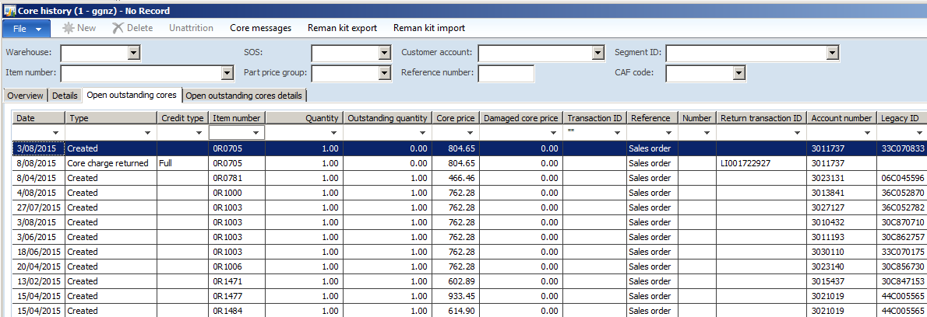

Create sales order to your customer.

Please enter the DBS document number as a reference in the NAXT Sales order.

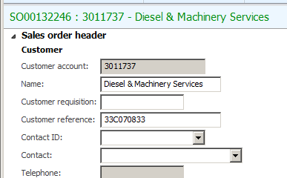

Go to inventory > Core return

The outstanding core will produce a line to return in the Core return overview tab.

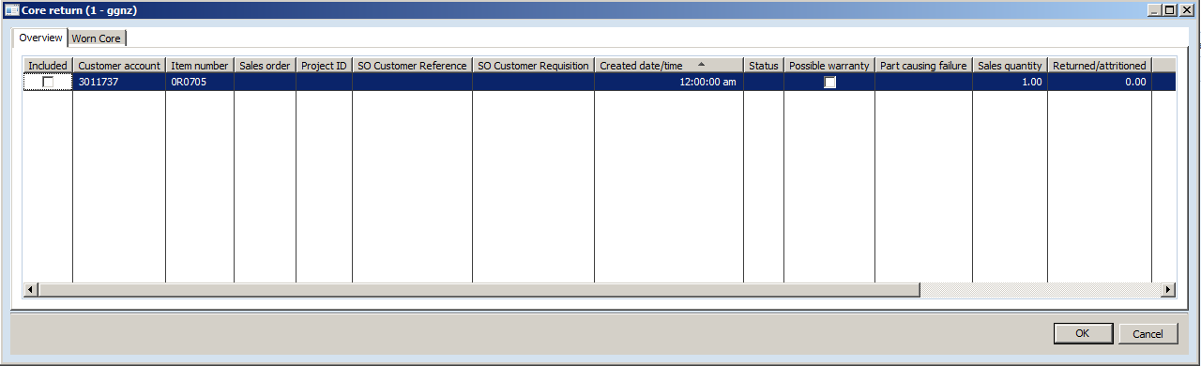

Tick the box before moving to the Worn core tab.

You can see the customer’s document number e.g. 33C070833 in the Legacy ID field.

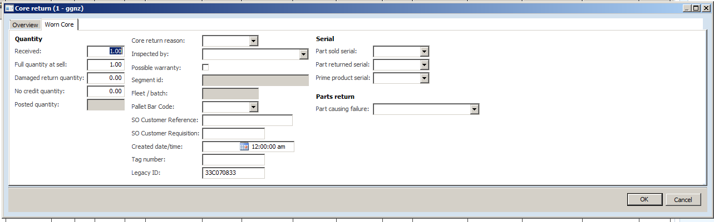

Process a core return as usual following SOP on intranet.

* *See PRT_9.1(SOP)Process a Core Return*